CONTACT – Media: |  |  |  |  |  |  | CONTACT – Investor Relations:
Amsterdam |  | +31.20.721.4488 | Brussels |  | +32.2.620.15.50 |  |  | +33.1.70.48.24.17
Dublin |  | +353.1.617.4266 | Paris |  | +33.1.70.48.24.45
Lisbon | +351.210.600.614
EURONEXT WELCOMES EDILIZIACROBATICA, ITS FIRST DUAL LISTING BY AN ITALIAN COMPANY, TO EURONEXT GROWTH

Market capitalisation: €30.7 million

Paris – 28 February 2019 – Euronext today welcomed EdiliziAcrobatica, the leading Italian company for safety rope access within the building industry, to Euronext Growth. EdiliziAcrobatica is the first Italian company with a dual listing on Euronext and on the Italian market.

Founded in 1994 in Genoa (Northwest Italy), EdiliziAcrobatica provides a wide range of services such as renovation, cleaning and maintenance of buildings, using the innovative technique of the double safety rope access. The company restores and maintains not only commercial offices, but also cultural buildings, monuments, hotels, hospitals and shopping centres. All the services are delivered by acrobatic rope access technicians without using bulky scaffolding. Today EdiliziAcrobatica counts 71 offices in Italy and aims to continue its expansion internationally.

EdiliziAcrobatica (ticker code: ALEAC) was listed on 28 February 2019 through the admission to trading of 6,525,300 shares making up its capital. The listing price was set at €4.70 per share. Market capitalisation on the day of listing was around €30.7 million.

At the listing ceremony, Riccardo Iovino, EdiliziAcrobatica’s CEO and founder said: "The listing on Euronext Growth is part of our European expansion, which is a key point of our strategy, and especially with a view to a future presence in France. On 19 November last year, during the opening ceremony of trading on the Italian Stock Exchange, I said that it was the 'ﬁrst quotation' of the company. Today, only three months later, EdiliziAcrobatica arrives on Euronext Growth with the same determination and the same values that have guided us during the last 25 years. We have always chosen to put at the centre of our attention the people who tirelessly, every day, work for us and with us. This choice is strategic, ethical and is the real key to the extraordinary growth of EdiliziAcrobatica”.

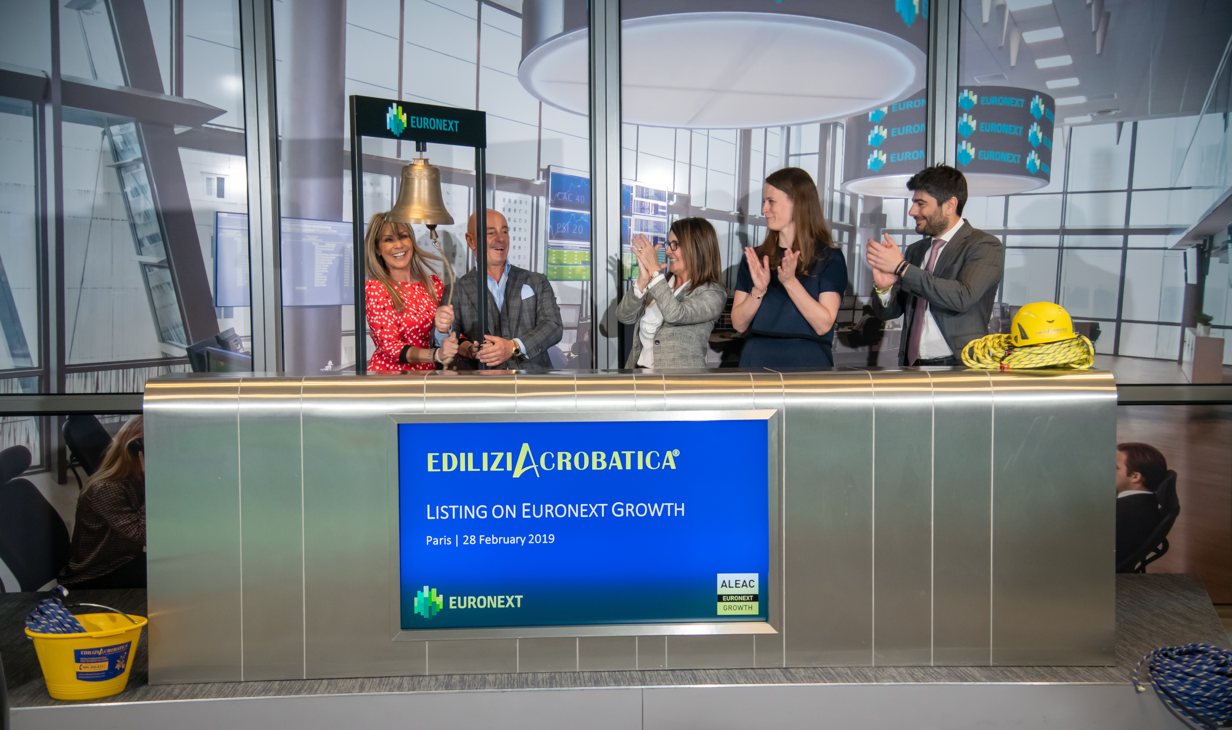

CONTACTS

Euronext
Pauline Bucaille +33 1 70 48 24 41 - pbucaille@euronext.com

EdiliziAcrobatica
Deborah Dirani +39 393 8911364 - ufficiostampa@ediliziacrobatica.com

About EdiliziAcrobatica
EdiliziAcrobatica® performs building renovation, cleaning and maintenance operations without the use of scaﬀolding or aerial platforms, using the innovative and cutting-edge technique of the double safety rope. This allows the end customer to access quality services with excellent standards and the obvious reduction of scaﬀolding cost, in addition to a series of intangible but priceless advantages: no visible obstacle, total freedom, light, cleanliness and total safety, even during the works. A real revolution in the building industry and a winning formula that is translated into numbers: in the last 9 months of 2018, EdiliziAcrobatica conﬁrmed the growing trend of the ﬁrst half of 2018 with revenues of around €18 million, an increase of 47.6% compared to the previous year’s revenues of approximately €12.2 million. The company has also increased its number of employees and collaborators to more than 650 people. The growth continues: EdiliziAcrobatica® is headquartered in Genoa and operates a total of 71 direct and franchised branches, representing an ever-expanding company that continues to create new job opportunities. www.ediliziacrobatica.com

About Euronext
Euronext is the leading pan-European exchange in the Eurozone, covering Belgium, France, Ireland, The Netherlands, Portugal and the UK. With 1,300 listed issuers worth €3.4 trillion in market capitalisation as of end December 2018, Euronext is an unmatched blue chip franchise that has 24 issuers in the Morningstar® Eurozone 50 Index℠ and a strong diverse domestic and international client base. Euronext operates regulated and transparent equity and derivatives markets and is the largest centre for debt and funds listings in the world. Its total product offering includes Equities, Exchange Traded Funds, Warrants & Certificates, Bonds, Derivatives, Commodities and Indices. Euronext also leverages its expertise in running markets by providing technology and managed services to third parties. In addition to its main regulated market, Euronext also operates Euronext GrowthTM and Euronext AccessTM, simplifying access to listing for SMEs.
For the latest news, find us on Twitter (twitter.com/euronext) and LinkedIn (linkedin.com/euronext)

Disclaimer
This press release is for information purposes only and is not a recommendation to engage in investment activities. This press release is provided “as is” without representation or warranty of any kind. While all reasonable care has been taken to ensure the accuracy of the content, Euronext does not guarantee its accuracy or completeness. Euronext will not be held liable for any loss or damages of any nature ensuing from using, trusting or acting on information provided. No information set out or referred to in this publication may be regarded as creating any right or obligation. The creation of rights and obligations in respect of financial products that are traded on the exchanges operated by Euronext’s subsidiaries shall depend solely on the applicable rules of the market operator. All proprietary rights and interest in or connected with this publication shall vest in Euronext.
This press release speaks only as of this date. Euronext refers to Euronext N.V. and its affiliates. Information regarding trademarks and intellectual property rights of Euronext is located at www.euronext.com/terms-use.
© 2019, Euronext N.V. - All rights reserved.

The Euronext Group processes your personal data in order to provide you with information about Euronext (the "Purpose"). With regard to the processing of these personal data, Euronext will comply with its obligations under the Regulation (EU) 2016/679 of the European Parliament and of the Council of 27 April 2016 (General Data Protection Regulation, “GDPR”), and any applicable national laws, rules and regulations implementing the GDPR as provided in its privacy statement available at: www.euronext.com/privacy-policy.
In accordance with the applicable legislation you have rights as regard to the processing of your personal data:
- for more information on your rights, please refer to: www.euronext.com/data_subjects_rights_request_information,
- for any request regarding the processing of your data or if you want to unsubscribe to this press release, please use our data subject request form https://connect2.euronext.com/form/data-subjects-rights-request or email our Data Protection Officer at dpo@euronext.com.

