CONTACT - Media: |  |  |  |  |  |  | CONTACT - Investor Relations:
Amsterdam | +31.20.721.4488 |  | Brussels |  | +32.2.620.15.50 |  | +33.1.70.48.24.17
Lisbon | +351.217.900.029 |  | Paris |  | +33.1.70.48.24.45
ACQUISITION OF WESTFIELD CORPORATION BY UNIBAIL-RODAMCO
New listed Group trades on Euronext
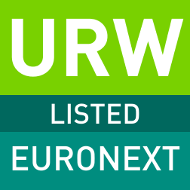

Amsterdam and Paris – 5 June 2018 – Following the successful acquisition of Westfield Corporation by Unibail-Rodamco, the new Group has been listed today on Euronext Amsterdam and Euronext Paris. The new Group opened the trading day in both Euronext marketplaces, which denotes the first trading day. The company aims to release its new branding on 7 June 2018.

Prior to the acquisition, Unibail-Rodamco was Europe’s largest listed commercial property company, with a presence in 11 continental European countries, and a portfolio of assets valued at €43.6 billion. Previously listed on the Australian Securities Exchange, Westfield’s portfolio comprises 35 shopping centres in select markets in the United States and the United Kingdom, valued at €18.4 billion¹. Together, the combined group creates the global premier developer and operator of flagship shopping destinations, with 102 shopping centres located in the world’s most dynamic cities across Europe and in the United States. In addition to its standing assets valued at €62 billion¹, the new Group has the world’s largest development pipeline, worth €13 billion as at 31 December 2017.

The new Group was admitted to listing and trading on the regulated market of Euronext in Amsterdam and in Paris, through the direct listing of 138,282,967 stapled shares, following the acquisition of Westfield. Market capitalisation was 26.3 billion on the day of listing.

Christophe Cuvillier, CEO of the new Group, said “The new Group brings together the two leaders in the retail property industry, forming the must have partner for international retailers and brands across Europe and select markets in the United States. With an unparalleled track-record and know-how in retail, offices and convention & exhibition, the new Group is ideally positioned to develop world-class projects. I look forward to June 7, and bringing together the teams of Unibail-Rodamco and Westfield.”

CONTACTS –

Euronext
Aïchata Tandjigora (Paris): +33 (0)1 70 48 24 43; atandjigora@euronext.com
Rosanne de Boer (Amsterdam): +31 (0) 20 721 4117; rdeboer@euronext.com

Unibail-Rodamco
Investor Relations
Maarten Otte
+33 1 76 77 58 02
maarten.otte@unibail-rodamco.com

Media Relations
Nathalie Feld
+33 1 76 77 57 94
nathalie.feld.contractor@unibail-rodamco.com

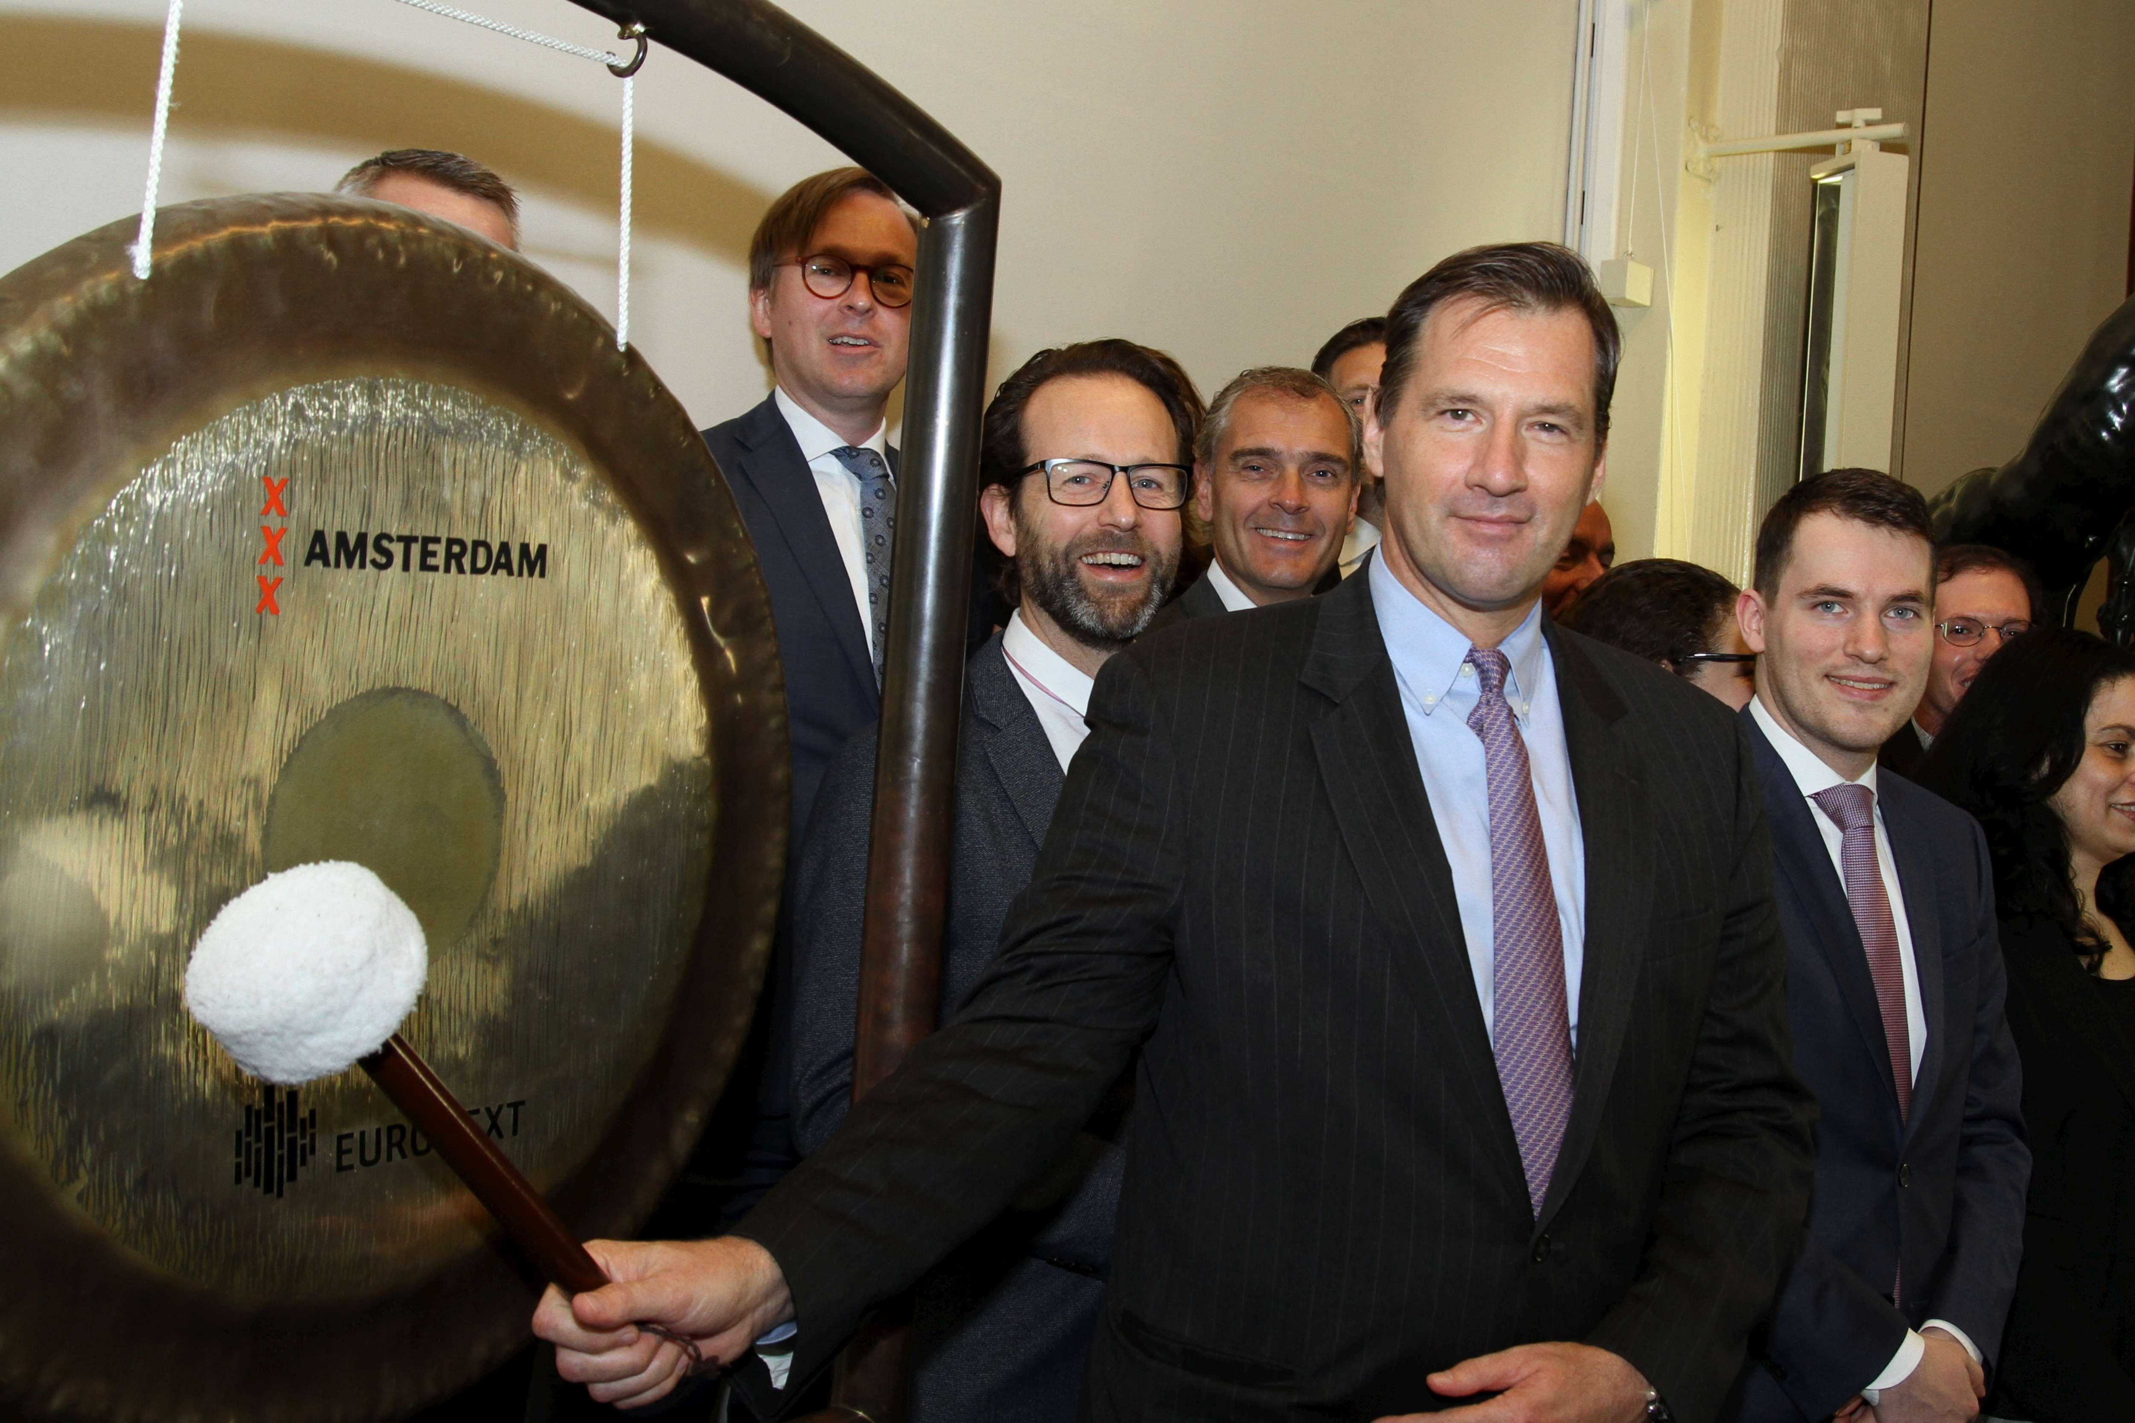
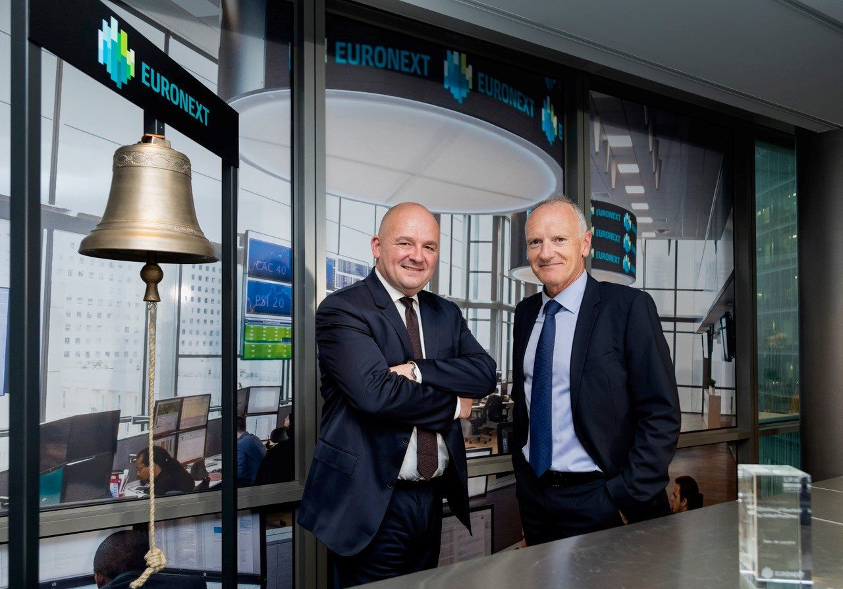

Opening Bell Ceremony and Gong Ceremony at Euronext Paris and Euronext Amsterdam, respectively.

About Euronext
Euronext is the leading pan-European exchange in the Eurozone, covering Belgium, France, Ireland, The Netherlands, Portugal and the UK. With 1,300 listed issuers worth €3.7 trillion in market capitalisation as of end March 2018, Euronext is an unmatched blue chip franchise that has 25 issuers in the Morningstar® Eurozone 50 Index℠ and a strong diverse domestic and international client base. Euronext operates regulated and transparent equity and derivatives markets and is the largest centre for debt and funds listings in the world. Its total product offering includes Equities, Exchange Traded Funds, Warrants & Certificates, Bonds, Derivatives, Commodities and Indices. Euronext also leverages its expertise in running markets by providing technology and managed services to third parties. In addition to its main regulated market, Euronext also operates Euronext GrowthTM and Euronext AccessTM, simplifying access to listing for SMEs.
For the latest news, find us on Twitter (twitter.com/euronext) and LinkedIn (linkedin.com/euronext).

Disclaimer
This press release is for information purposes only and is not a recommendation to engage in investment activities. This press release is provided “as is” without representation or warranty of any kind. While all reasonable care has been taken to ensure the accuracy of the content, Euronext does not guarantee its accuracy or completeness. Euronext will not be held liable for any loss or damages of any nature ensuing from using, trusting or acting on information provided. No information set out or referred to in this publication may be regarded as creating any right or obligation. The creation of rights and obligations in respect of financial products that are traded on the exchanges operated by Euronext’s subsidiaries shall depend solely on the applicable rules of the market operator. All proprietary rights and interest in or connected with this publication shall vest in Euronext.
This press release speaks only as of this date. Euronext refers to Euronext N.V. and its affiliates. Information regarding trademarks and intellectual property rights of Euronext is located at www.euronext.com/terms-use.
© 2018, Euronext N.V. - All rights reserved.

Proportionate GMV. Includes investments in shopping centres, assets under construction, assets held for redevelopment and inventories

