EURONEXT EIM serviceS AGREEMENT

ORDER FORM AND DESCRIPTION OF SERVICES

PREAMBLE - ELIGIBILITY REQUIREMENTS
0.1 Within Euronext EIM Services, the Euronext Group has developed a Euronext Inventory Management (“EIM”) System to facilitate the management of the Euronext’s current commodity futures contracts. The EIM System manages in particular the document which may have to be submitted by the Approved Silos under the responsibility of the Clearing Member in the delivery process to confirm the ownership of commodities and provide the Clearing Organisation with assurance that those with expiring short positions have the material required to go to delivery.
0.2 The EIM Services are limited to the following Clients:
- Approved Silos;
- Clearing Members;
- the Ordering Parties or Issuers as designated by the Clearing Members;
- Clearing Organisations;
- Credit Institutions;
- Trading Members

The nature of the Client is defined below in the article "Nature and Client Information".
(this Order Form contains only the Appendix 1)

0.3 This Order Form and Description of Services is governed by the Terms and Conditions signed by and between the Client [<name>__________________________________] and Euronext Paris SA on [July 1st, 2024] :
In case of any conflict or discrepancy between the terms of the General Terms and Conditions and the terms of this Order Form and Description of Services, the latter shall prevail.
Capitalised terms defined in this Order Form and Description of Services have the same meanings when used in the General Terms and Conditions and vice versa.
- LIMITATION OF AUTHORIZED USERS
Authorized Users appointed by Client shall not exceed a number of five (5).
- NATURE AND CLIENT INFORMATION
☐ The Client or the Authorized User is an [Approved Silo (the Order Form contains only Appendix 1)].
☐ The Client or the Authorized User is a [Clearing Member (the Order Form contains only Appendix(ces) _________)].
☐ The Client or the Authorized User is an [Ordering Party or Issuer (the Order Form contains only Appendix(ces) _________)].
☐ The Client or the Authorized User is a [Clearing Organisation (the Order Form contains only Appendix(ces) _________)].
☐ The Client or the Authorized User is a [Credit institution (the Order Form contains only Appendix(ces) _________)].
☐ The Client or the Authorized User is a [Trading member (the Order Form contains only Appendix(ces) _________)]

Applicant’s statutory name and legal form:
Commercial name (if different):
V.A.T. (tax) registration number:
LEI or CICI code (applicable to Clearing Members):
Registered address:
Business address (if different):
Switchboard telephone no.:
Website address:
Generic company email address:

- REPRESENTATIVES
According to the General Terms and Conditions, names and contact details of two (2) persons dedicated to the performance of the Agreement, including notices (this information needs to be kept up-to-date at all times) are:
 | Business Contact | Technical Contact  ☐ same as Business Contact
Name:
Job Title:
Telephone:
Email:
Address 1 (postal address):
Address 2 (carrier address):

- EURONEXT INFORMATION
All notices by the Client to Euronext shall be sent to the following Euronext contact:
Name: | Euronext Membership Department
Address: | Beursplein 5, 1012 JW Amsterdam, Netherlands
Telephone: | + 31 20 721 4264 / +33 1 70 48 25 05
Email: | EuronextMembership@euronext.com

- DESCRIPTION OF SERVICES
The following description of the Services is correct at the date on which the Agreement comes into effect. The levels of which as set out in this Section are only targets and Euronext does not guarantee any level of availability or reliability of the Services.
- ELECTRONIC STORAGE CERTIFICATES
- Euronext traded commodity contracts are settled by the exchange of commodities from export storage locations.
- The commodities are deposited, mainly by Issuers or Ordering Parties, into inland silos for medium term storage, or port located silos for export.
- The material in a single silo may be owned by multiple parties and is ‘co-mingled’ or ‘unmarked’
- Approved Silos use the Services to issue electronic Storage Certificates allowing the holder proof of ownership of a specified volume of the relevant commodity.
- Clearing Members use the Services to demonstrate to the Euronext clearing counterparty that they have sufficient volume of the relevant commodity in a delivery location to cover or satisfy their positions on the relevant Euronext commodity futures.
- The Clearing Organisation uses the Services to assist in the management of the settlement of commodity futures and the delivery of the underlying commodities through a comparison between electronic Storage Certificates issued via the Services and short expiring positions.
- AUTHORIZED USERS ROLES
Without prejudice to the roles of the Authorized Users as defined in the EIM Rules, the Parties agree on the mechanisms of intervention of the Authorized Users as follows:
- Approved Silos
The Services will allow Approved Silos to have the ability to create electronic Storage Certificates providing proof of ownership of a specified volume of the relevant commodity stored in a facility under their control and management.
The Services will allow Approved Silos to nominate the Storage Certificates in the Software to Clearing Members who own the commodities.
- Ordering Party or Issuers
The Services will allow Ordering Parties or Issuers to obtain the Storage Certificates issued by the Approved Silos on their behalf in the Software corresponding to the commodities, goods and materials stored by the Approved Silos, in order to be able to transmit them to their Clearing Member. Use of the Services by Ordering Parties or Issuers is authorised by the Clearing Member and each Storage Certificate issued by the Approved Silo at the request of an Ordering Party or Issuer is validated by the Clearing Member.
- Clearing Members
The Services will provide Clearing Members with the ability to hold and present to the Clearing Organisation the electronic Storage Certificates created by Approved Silos that evidence the ownership in commodities, goods and materials stored in the Approved Silos.
- Clearing Organisation
The Services provides the Clearing Organisation with facilities to manage the contract settlement process for commodity futures cleared by the Clearing Organisation. Key function includes tracking the Storage Certificates of Clearing Members with short positions.
- Trading Members
The Services will enable non clearing Trading members to facilitate and organise bilateral arrangements to exchange quantity of contracts for delivery before the final matching of counterparties.
- Availability and reliability of the services

The levels of which as set out in this Section C are only targets and Euronext does not guarantee any level of availability or reliability of the Services.
- The Services allow the electronic production and management of Storage Certificates during the following operating hours and day:
Any Business Day is from (06:30 CET +1) to 22:30 (CET +1). References to times of day are to Central European Time (CET).
- In this Section C, the following terms have the following meanings:
- “Availability” means the period in which the Services are available as expressed as a percentage of the service period. The baseline period is one calendar year. Availability is measured within the Support Operating Hours described in Section E of this Appendix (Support Services).
- “Reliability”: A quantitative measure of the number of major technical incidents of the Services during the Support Operating Hours described in Section E of this Appendix (Support Services) within a given period. The Services reliability is determined with respect to the Services technical suspensions.
- Service Period:
- The period’s availability equates to a target availability of 98% per calendar year.
- The target reliability allows 1 service interruption per month.
- Services downtime or interruption attributable to third parties (including without limitation service providers other than Euronext sub-contractors) are not included in the availability and reliability calculations.
- SECURITY FEATURES AND BACKUPS
- Backups
Notwithstanding the back-ups made by Euronext, it is vital that the Client implements procedures to back up Client Information and Storage Certificates that it has issued, including by printing or computer storage.
Accordingly, the Client should draft a back-up plan.
In order to ensure operational continuity, the Client’s back-up processes must meet the following requirements:
- back-up procedures are carefully documented and regularly tested; the reports on these tests are provided to Euronext at its first request;
- back-up copies made by the Client receive the same level of protection as originals.
- Administration of logical access authorisations
The Client must implement a procedure for choosing secure passwords in accordance with good industry practice including industry generally accepted system security principles. Passwords also follow the applicable principles and procedures defined in the EIM Rules and in particular those relating to the periodicity of the update of such passwords.
The Client shall ensure that passwords are not written on easily accessible documents and shall change passwords regularly to minimise the risk of unauthorised access.
The Client must implement an access control policy to mitigate the risks of unauthorised access to the Services. This access policy must include provisions covering password management, use and transmission and passwords must be regularly changed.
The Client assumes full responsibility for investigating requests for authorisation to access its computer resources, regardless of the origin of such requests, and retains sole responsibility and control over the action to be taken in responding to any requests deemed to be legitimate.
The Client shall immediately inform Euronext of any attempted breach of access rights that comes to its attention.
The Client and Euronext will jointly investigate all attempts at unauthorised access with a view to identifying the sources and reasons for such attempts and then taking the most appropriate action.
The Client shall define the values for the parameters governing the practical functioning of its security systems, for example, the frequency of required password changes and the number of authorised unsuccessful logon attempts.
- User group access rights
The Services identify users uniquely with role-based access control defined by their user type. User group access rights (permitted or prevented access) are defined in the Services and in detail in the relevant User Guide. The Client shall provide Euronext with a permanent valid email address for the duration of the Services.
- Archives
For regulatory compliance purposes, Euronext endeavours to archive the Client Information and store this information on its secure premises, as well as logs of the Clients to the Software, the Storage Certificates processed via the Services, notifications of all kind produces by the Software, as agreed upon in the User Guide, and to make all such records available to the Clearing Organisation upon request, for a period not less than the time period from its issuance as required or set by the regulatory authorities. Two archive copies are made. As mentioned above, however, the Client should have back up procedures relating to its Client Information.
Euronext may transfer the logs of a Client to the Clearing Organisation to the extent they have been anonymised (i) at the request of a Regulatory body and/or (ii) in case of a Client claim against the Clearing Organisation and/or Euronext.
Client Information is archived on digital media.
- Security procedures and methods implemented by Euronext
Euronext has implemented security procedures and methods (described below) in order to allow Clients secure access to the Services. The security features and procedures implemented by Euronext or its subcontractors are compliant with standard, generally accepted system security principles for the industry.
The information security management programme at Euronext preserves the confidentiality, integrity and availability of information by applying a risk management process and gives confidence to interested parties that risks are adequately managed. It is important to note that the Euronext information security management programme forms part of, and therefore is integrated with, Euronext’s business processes and overall governance, risk, and compliance (GRC) framework.
Database encryption is performed and applied to Authorized Users credential data.
Information Security is considered in the design of all processes, information systems, and controls at Euronext, and Euronext always endeavour to ensure that the information security management programmes implementation is operationally scaled in accordance with the strategy and requirements of Euronext plus the expectations of its clients, business partners, and regulators, as well as all pertinent legislation in this area.
In any case, the Euronext Security procedures, policies and standards as attached to the Agreement shall be enforceable.

- Security of the premises
Notwithstanding Euronext applicable Security procedures, policies and standards All access to the information centre of Euronext, as well as the service rooms, is physically secured by the use of proximity cards.
Two back-up access systems are in operation, which allow daily traceability of all incoming and outgoing movements:
- Back-up on hard disk
- Back-up on paper printouts.
This data is kept for one (1) year.
- Security of the electronic Storage Certificates
The electronic Storage Certificates processed through the Software are delivered in a tamper and forgery resistant PDF Format.
- SUPPORT SERVICES

As stated above, the levels of which as set out in this Section E are only targets.
Call management
Euronext will make available by telephone, email or such other means as Euronext may from time to time determine, a support service from the relevant Euronext support team (the “Support Service”) to enable the Client to place calls and receive assistance with incidents relating to the Services.
In this Section E, a contact made to the Support Service, whether by telephone, email or otherwise, is referred to as a “Call”.
The Support Service will normally be available to receive Calls during the operating hours set out below. The details for making Calls are also set out below.
Contact Details
Contact details for the Support Service are as follows:
Email: serviceoperations@euronext.com
Telephone: +44 20 7660 8588

Support Operating Hours
References to times of day are to Central European Time (CET). Client can contact the Support Service during the following support operating hours and days: any Business Day from 08:30 CET + 1 to 19:00 CET +1.
Incident management
Calls that the Support Service is unable to resolve immediately will be logged by the Support Service in Euronext Incident Management system, identified with a reference number. The number will be communicated to the Client and then used in all references to the Call and its management.
The Incident shall contain a reasonable description of the effects observed and their impact on the operation of the Services.
Euronext takes all necessary measures and provides information useful in resolving the Call until the Call is resolved.
Certain Calls requiring an in-depth analysis may require the use of a test environment aimed at reproducing the malfunction.
Incident Severity levels
The types of severity levels and the response measures as described below are also provided on a best effort basis (obligation de moyen):
- A Severity 1 produces an emergency situation in which the Services are wholly inoperable or unable to facilitate electronic production and management of Storage Certificate used in the Clearing Organization delivery process. Euronext shall promptly inform the Clearing Organisation or the relevant Representative by telephone or by email or otherwise.
- A Severity 2 produces a situation in which the function or performance (throughput or response time) of the Services degrades substantially under reasonable loads, such that there is a severe impact on use for the Services concerned; the Services are usable, but materially incomplete or degraded; one or more principle functions is inoperable or severely degraded. In this situation, the Clearing Organisation and Euronext will agree on notifying Clients by telephone or by email or otherwise.
- A Severity 3 is any other Incident.
Severity | Response Time Target | Issue Resolution Target
1 | ≤60 minutes in Support Hours | ≤ 2 hours in Support Operating Hours
2 | ≤ 2 hours in Support Hours | ≤ 4 hours in Support Operating Hours
3 | ≤ 1 business Day | ≤ 20 hours in Support Operating Hours
Incident Resolution means a fix, workaround, or recovery support.
Exceptions
The support service does not cover interventions due to deterioration or malfunction resulting from the following events:
(i) failure to use the Software and, in general, any use that does not comply with the Documentation and the EIM Rules, or whose use is manifestly unreasonable or disproportionate to the characteristics of the Software;
(ii) any assistance operation carried out by a person outside Euronext or not authorised by it;
(iii) the use of unsuitable servers, CPUs, peripherals, controllers or accessories; (
(iv) damage caused by incompatibility or malfunction of the Client's software connected to the Software;
(v) any connection work and/or repairs to the Software not attributable to Euronext;
(vi) any work (labour and travel) requested outside Euronext's working hours.
Without prejudice to the contractual provisions, any intervention arising out of a deterioration or malfunction caused by the occurrence of one of the above-mentioned cases will be invoiced additionally by Euronext at the rate applicable on the day of the intervention. Euronext shall have no obligation concerning deterioration or malfunction due to the occurrence of one of the cases mentioned above.

- Contingency procedure
In the event that any Severity 1 or 2 Incident occurs two (2) hours prior to critical delivery timeline of Storage Certificates as per the Clearing Rules, the Client accepts without any caveat that the Clearing Organisation and the Client shall automatically apply the present contingency procedure.
The Clearing Organisation and the Clients must use the alternative procedure by email for the issuance of Storage Certificates as a workaround solution, as described in the Clearing Rules (including but not limited to any modification of Storage Certificates which have been previously approved by the Clearing Organisation through the Services) or those of the Clearing Organisation. The Clearing Organisation will communicate the technical disruption status by email to Clients.

- CHARGES
The Services are provided for the amount equal to: Euros 250/year (for five Authorised Users)
The Services are also subject to the applicable fee grid and/or the fees as set out in the public price list on the Euronext website.
Charges may vary in accordance with the terms set out in the General Terms and Conditions.

- TERM
The Parties hereby agree that the present Order Form and Description of Services, and the Agreement enter into effect on July 1st, 2024. (the “Effective Date”).
The duration of the Services covered by this Order Form and Description of Services is unlimited from the aforementioned Effective Date.
The term of the Services shall end in accordance with the conditions set out in the Agreement or in the event Euronext notifies to the Client or the Authorized User cease of EIM System use.

- GoVERNING LAW AND JURISDICTION
The construction, validity and performance of this Agreement shall be governed in all respects by the laws of France.
The French Courts shall have exclusive jurisdiction to settle any dispute, controversy or claim arising out of or in connection with this Agreement.

- CONTRACTUAL DOCUMENTS
The Agreement consists of:
- The Order Form and Description of Services; and
- The General Terms and Conditions and any and all appendices and other addenda to it as may be varied from time to time in accordance with the provisions of the Agreement.
In case of any conflict or discrepancy the terms of the General Terms and Conditions and the terms of the Order Forms and Description of Services, the terms of the Order Form and the Description of Services shall prevail over the General Terms and Conditions.

EURONEXT PARIS SA  Signature of authorized person | CLIENT  Signature of authorized person
Print Full Name: __________________________  Job Title: ______________________________  Date: | Print Full Name: __________________________  Job Title: ______________________________  Date:

Appendix 1: MODEL FORM FOR
Member Connectivity Administrator (MCA) for Euronext EIM Services
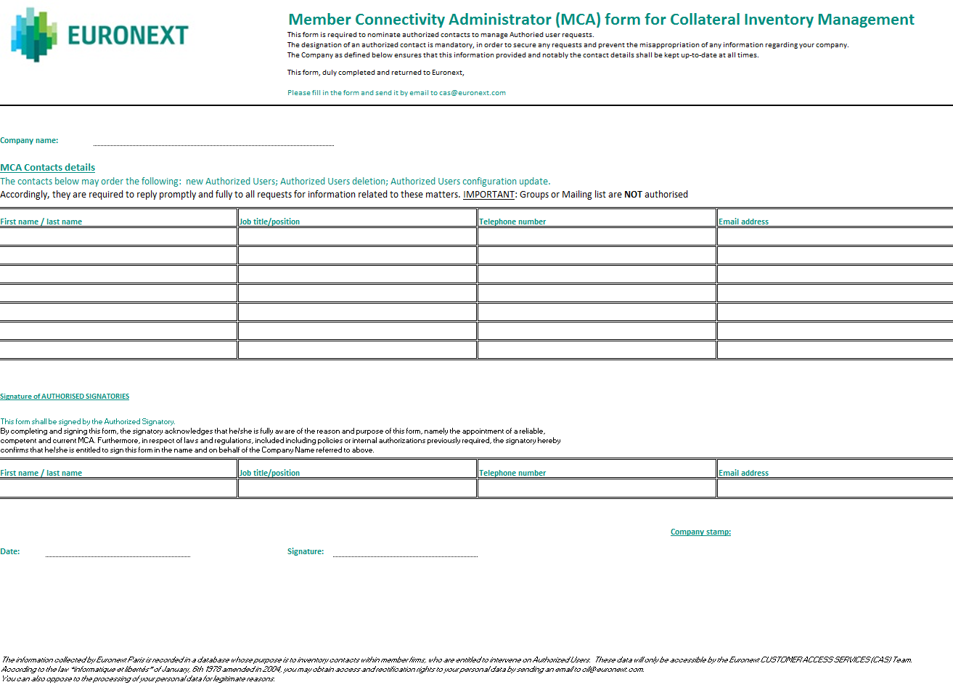

Timelines are clearly defined in the relevant Clearing Organisation’s Notices, which are, for Corn and Milling Wheat N°2, D-5 (5 pm) or D-1 (5 pm) for positions of +/- 100 lots

